1. Open the folder containing the script.
   1. There should be the two following scripts inside the folder.



1. Make sure that the input file (“input.xlsx”) exist and filled with the desired data for your test
2. At the windows explorer’s address line, type "CMD" and press Enter.

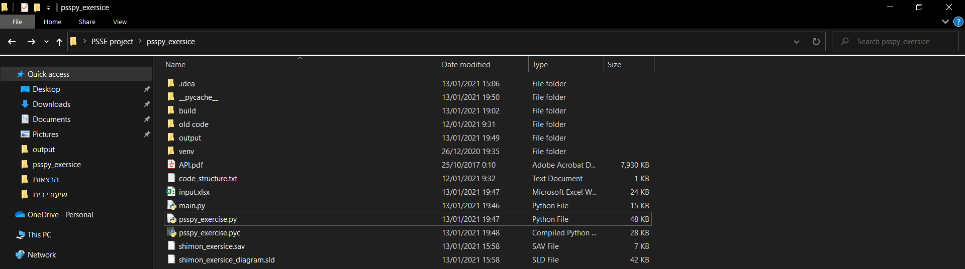

*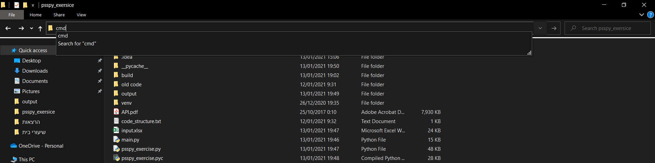 *

1. At the opened windows type “py -2 main.py” and press Enter
   1. 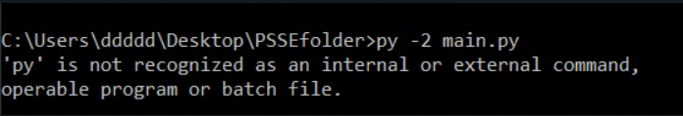In case of having the following error:
      1. Find the folder where your python 2.7 is installed.

* Usually, it is C:\Python27
  + 1. Copy the address to the same CMD window mentioned above.
    2. Add “\python.exe” to the address.
    - For example: C:\Python27\python.exe
    1. Add “main.py” and press Enter.

1. The results should appear at the output folder.
   1. In case that the output folder does not exist, the code would create it